PCA + Logistic Regression
How many principal components to keep, and how does model performance change?
Wisconsin Breast Cancer Diagnostic Dataset — 569 samples · 30 features · Binary target

1. Why apply PCA before Logistic Regression?
The Wisconsin Breast Cancer dataset contains 30 features derived from the same 10 nuclear characteristics (mean, SE, and worst values for each). This design deliberately creates high multicollinearity — radius, perimeter, and area, for example, are nearly perfectly correlated because perimeter ≈ 2π×radius and area ≈ π×radius².

Logistic Regression assumes that predictors contribute independent information. When features are highly collinear, coefficient estimates become unstable and the model can overfit. PCA addresses this by transforming the original 30 correlated features into a smaller set of uncorrelated principal components, each capturing a distinct direction of variance.

Dimensionality reduction | Multicollinearity removed | Noise suppression
30 correlated features → k uncorrelated PCs, where k << 30 | PCs are orthogonal by construction — no two PCs share information | Minor PCs capture noise; dropping them can improve generalisation

Pipeline used throughout
StandardScaler → PCA(n) → LogisticRegression, evaluated with 10-fold stratified cross-validation. Standardisation is applied inside each fold to prevent data leakage.

2. How much variance does each PC capture?

2.1 Eigenvalues and explained variance
After standardising the 30 features, PCA decomposes the covariance matrix into 30 eigenvalue–eigenvector pairs. The eigenvalue of each PC equals the variance it captures. Because the features were standardised, the total variance is 30 — so an eigenvalue of 1.0 means a PC captures as much variance as a single original feature.

PC | Eigenvalue | Var% | Cum% | vs 1.0 | Kaiser?
PC01 | 13.3050 | 44.27% | 44.27% | 13.3 > 1 | Yes
PC02 | 5.7014 | 18.97% | 63.24% | 5.7 > 1 | Yes
PC03 | 2.8229 | 9.39% | 72.64% | 2.8 > 1 | Yes
PC04 | 1.9841 | 6.60% | 79.24% | 2.0 > 1 | Yes
PC05 | 1.6516 | 5.50% | 84.73% | 1.7 > 1 | Yes
PC06 | 1.2095 | 4.02% | 88.76% | 1.2 > 1 | Yes | ← last Kaiser PC
PC07 | 0.6764 | 2.25% | 91.01% | 0.68 < 1 | No
PC08 | 0.4775 | 1.59% | 92.60% | 0.48 < 1 | No
PC09 | 0.4176 | 1.39% | 93.99% | 0.42 < 1 | No
PC10 | 0.3513 | 1.17% | 95.16% | 0.35 < 1 | No | ← 95% threshold
PC11 | 0.2944 | 0.98% | 96.14% | 0.29 < 1 | No
PC12 | 0.2616 | 0.87% | 97.01% | 0.26 < 1 | No
PC13 | 0.2418 | 0.80% | 97.81% | 0.24 < 1 | No
PC14 | 0.1573 | 0.52% | 98.34% | 0.16 < 1 | No
PC15 | 0.0943 | 0.31% | 98.65% | 0.09 < 1 | No

2.2 How many PCs to keep — decision rules

Criterion | PCs kept | Cum. variance | Recommended? | Comment
Kaiser (eigenvalue > 1) | 6 | 88.8% | Good starting point | Theoretical grounding; widely taught
80% variance threshold | 5 | 84.7% | Minimal | May lose important signal
90% variance threshold | 7 | 91.0% | Acceptable | Practical for large datasets
95% variance threshold | 10 | 95.2% | Recommended | Matches full-feature AUC
99% variance threshold | 17 | 99.1% | Diminishing returns | Adds noise-dominated PCs
All 30 features | 30 | 100% | Baseline | No dimensionality reduction

Why 10 PCs is the sweet spot
PCs 1–10 collectively explain 95.2% of the total variance. PCs 11 onwards each contribute less than 1% and mainly capture measurement noise. As the LR performance analysis confirms (Section 4), adding PCs beyond 10 produces negligible or negative changes in AUC.

3. Visual analysis

3.1 Scree plot and cumulative variance
The scree plot (left) shows eigenvalues dropping steeply from PC1 through PC6, then levelling off below 1.0 — the classic 'elbow' that marks the Kaiser cut-off. The cumulative variance plot (right) shows the three commonly used thresholds: 80%, 90%, and 95%.

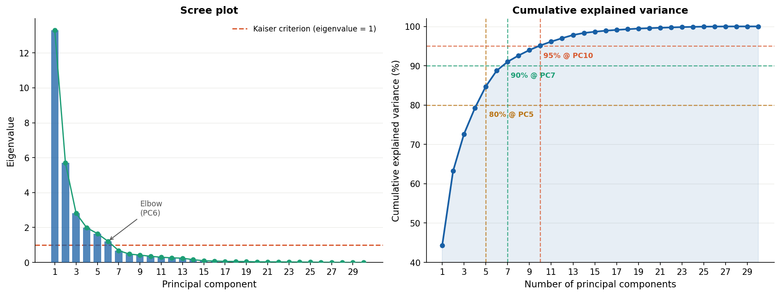
Figure 1 — Scree plot (left) and cumulative explained variance (right). Dashed lines mark the Kaiser criterion and variance thresholds.

3.2 PCA biplot — PC1 vs PC2
The biplot projects all 569 patients into the 2-dimensional space of PC1 and PC2. Coloured by diagnosis, the two classes are already largely separated along PC1 alone — confirming that PC1 (44.3% variance, dominated by size features like radius, perimeter, and area) is the strongest single discriminating component. Loading arrows show which original features drive each PC.

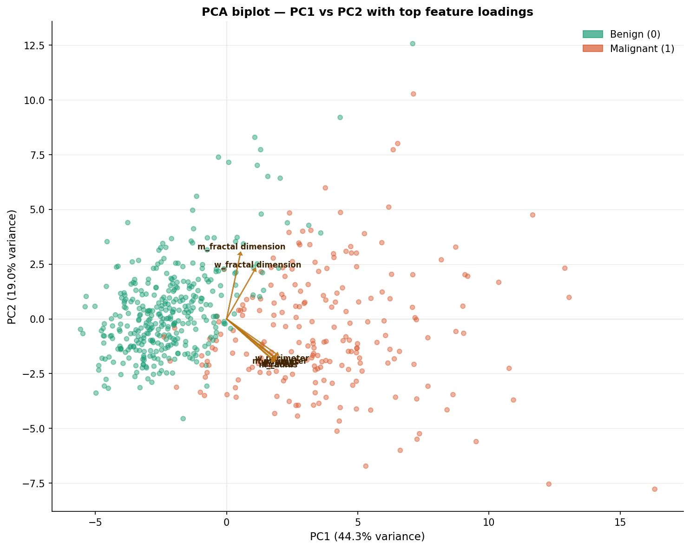
Figure 2 — PCA biplot (PC1 vs PC2). Points coloured by diagnosis; arrows show top-8 feature loadings scaled for visibility.

3.3 Loading heatmap — PC1 to PC10
The heatmap shows how each original feature loads onto PCs 1 through 10. Red indicates a positive loading (feature pushes the PC score up), blue indicates a negative loading. PC1 loads uniformly and positively on size features. PC2 loads strongly on texture and symmetry. Later PCs pick up increasingly specific combinations.

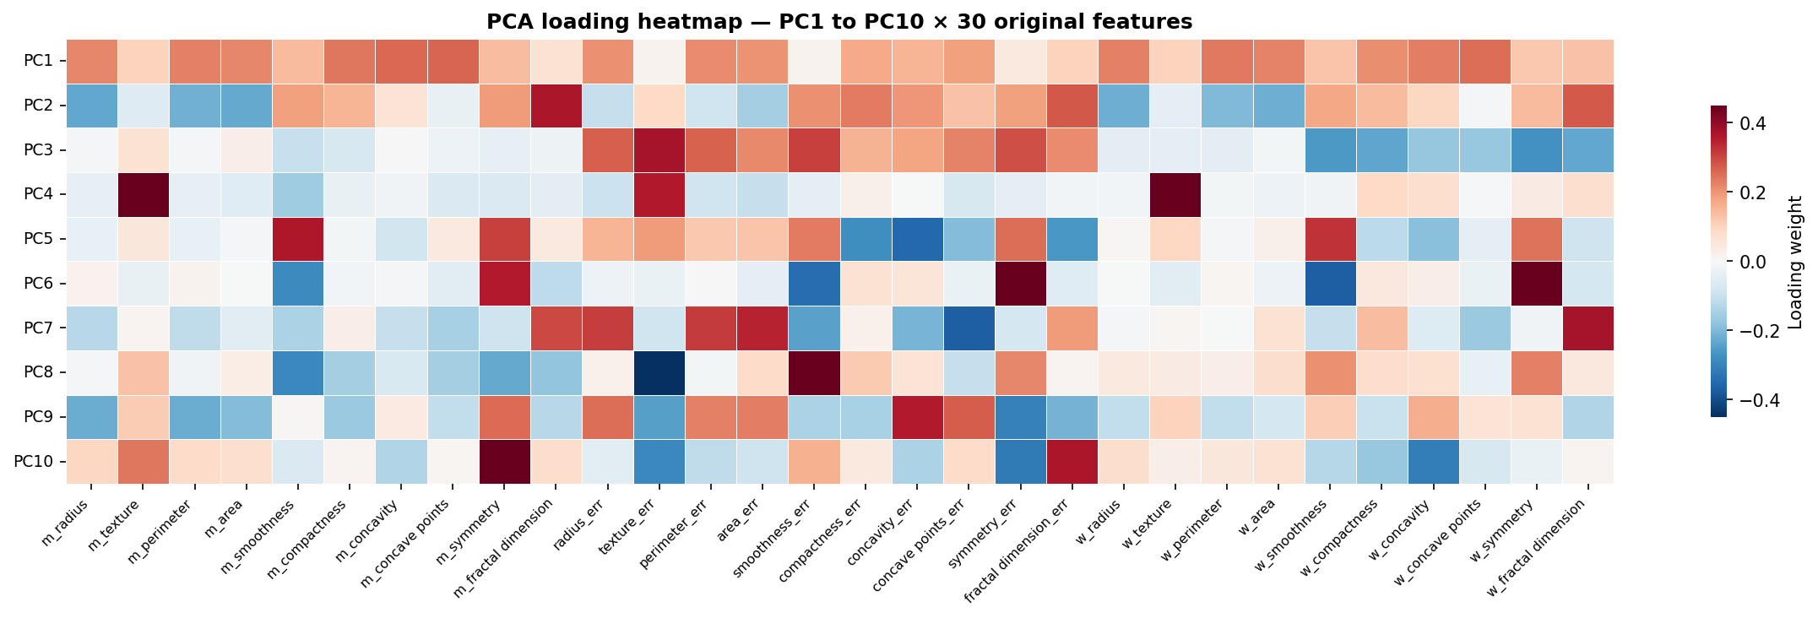
Figure 3 — Loading heatmap for PC1–PC10. Each cell shows the weight of an original feature in each principal component.

4. Logistic Regression performance vs number of PCs
The table below shows 10-fold stratified cross-validation results for Logistic Regression at each PC count from 1 to 30. The pipeline is StandardScaler → PCA(n) → LogisticRegression (lbfgs, max_iter=5000) at every step.

PCs | Cum% | Accuracy | Precision | Recall | F1 | AUC | Note
PC1 | 44.3% | 0.9122 | 0.9392 | 0.8773 | 0.8774 | 0.9697 | PC1 only — size signal alone
PC2 | 63.2% | 0.9491 | 0.9579 | 0.9203 | 0.9303 | 0.9902 | Big jump adding texture PC
PC3 | 72.6% | 0.9491 | 0.9551 | 0.9203 | 0.9306 | 0.9921 | Marginal gain
PC4 | 79.2% | 0.9632 | 0.9688 | 0.9389 | 0.9491 | 0.9941 | Crosses 80% variance
PC5 | 84.7% | 0.9632 | 0.9693 | 0.9389 | 0.9504 | 0.9942 | Crosses 85% variance
PC6 | 88.8% | 0.9684 | 0.9737 | 0.9479 | 0.9574 | 0.9942 | Kaiser threshold
PC7 | 91.0% | 0.9684 | 0.9743 | 0.9479 | 0.9567 | 0.9941 | Crosses 90% variance
PC8 | 92.6% | 0.9719 | 0.9773 | 0.9527 | 0.9614 | 0.9949 | Steady improvement
PC9 | 94.0% | 0.9772 | 0.9795 | 0.9621 | 0.9690 | 0.9955 | Acc matches baseline
PC10 | 95.2% | 0.9789 | 0.9811 | 0.9621 | 0.9711 | 0.9947 | AUC matches baseline
PC11 | 96.1% | 0.9789 | 0.9809 | 0.9621 | 0.9711 | 0.9951 | Performance plateau
PC12 | 97.0% | 0.9789 | 0.9824 | 0.9621 | 0.9711 | 0.9949 | Plateau continues
PC13 | 97.8% | 0.9754 | 0.9801 | 0.9574 | 0.9666 | 0.9951 | Slight dip
PC15 | 98.7% | 0.9789 | 0.9820 | 0.9621 | 0.9705 | 0.9951 | Near-baseline
PC20 | 99.6% | 0.9754 | 0.9801 | 0.9574 | 0.9659 | 0.9949 | No gain over 10 PCs
PC30 | 100.0% | 0.9754 | 0.9820 | 0.9574 | 0.9659 | 0.9947 | Full data — same as baseline

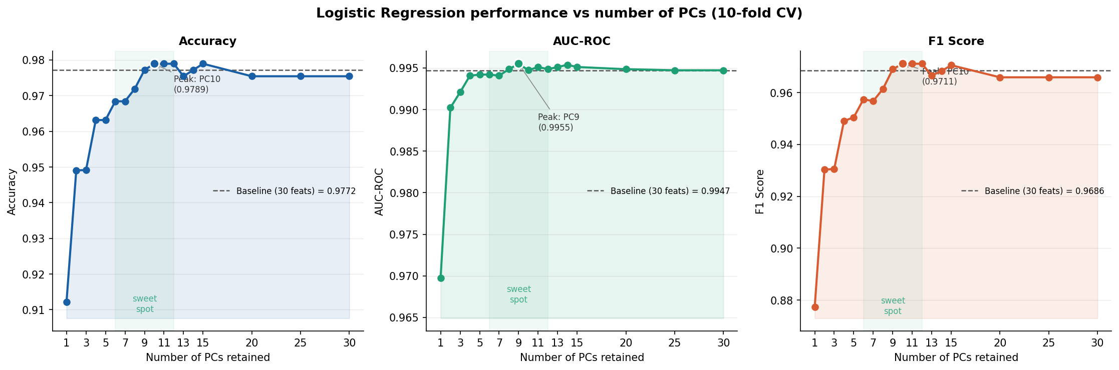
Figure 4 — Accuracy, AUC-ROC, and F1 as a function of retained PCs. Dashed line = baseline (no PCA). Shaded region = sweet spot (PC6–PC12).

5. Interpreting the results

5.1 Key inflection points

PCs | Cum.Var | Accuracy | AUC | F1 | What changes
1 | 44.3% | 0.9122 | 0.9697 | 0.8774 | Only PC1 used — size features. Strong signal but misses texture.
2 | 63.2% | 0.9491 | 0.9902 | 0.9303 | PC2 adds texture/symmetry. Large jump in both Accuracy and AUC.
6 | 88.8% | 0.9684 | 0.9942 | 0.9574 | Kaiser threshold. Good balance — AUC nearly at ceiling.
10 | 95.2% | 0.9789 | 0.9947 | 0.9711 | AUC matches full 30-feature baseline exactly. Recommended.
11 | 96.1% | 0.9789 | 0.9951 | 0.9711 | Performance plateau reached. Adding more PCs offers no gain.
30 | 100% | 0.9754 | 0.9947 | 0.9659 | All 30 features, no PCA. Slightly lower Acc than PC10 — noise effect.

5.2 Why performance plateaus at PC10–11
Once 95% of variance is captured (PC10), each additional component contributes less than 1% new variance and mostly encodes measurement noise and minor inter-patient variation. Adding these noise-dominated PCs can actually hurt Logistic Regression slightly — as seen at PC13 and PC20, where Accuracy dips marginally below the PC10 peak.

This plateau is specific to the breast cancer dataset's redundancy structure. In a dataset where every feature was truly independent, performance would continue improving with each added PC. The rapid plateau here reflects how much overlapping information the 30 features contain.

The full-data paradox
Using all 30 features without PCA (Accuracy = 0.9754, AUC = 0.9947) scores lower on Accuracy than PCA(10) (Accuracy = 0.9789). This happens because PCA's denoising effect — discarding the bottom 5% of variance — improves Logistic Regression's coefficient stability on this highly collinear dataset. PCA is doing double duty: reducing dimensions AND acting as a regulariser.

6. Recommended pipeline
Based on the full analysis, the recommended pipeline for this dataset is:

from sklearn.pipeline import Pipeline
from sklearn.preprocessing import StandardScaler
from sklearn.decomposition import PCA
from sklearn.linear_model import LogisticRegression
from sklearn.model_selection import StratifiedKFold, cross_validate

# Recommended: 10 PCs captures 95.2% variance, matches full-feature AUC
pipe = Pipeline([
('scaler', StandardScaler()), # mandatory before PCA
('pca', PCA(n_components=10)), # 10 PCs = 95.2% variance
('lr', LogisticRegression( # logistic regression
max_iter=5000,
solver='lbfgs',
random_state=42))
])

# Evaluate with 10-fold stratified CV
skf = StratifiedKFold(n_splits=10, shuffle=True, random_state=42)
results = cross_validate(pipe, X, y, cv=skf,
scoring=['accuracy','precision','recall','f1','roc_auc'])

# Results: Accuracy=0.9789, AUC=0.9947, F1=0.9711

Accuracy | Precision | Recall | F1 | AUC
0.9789 | 0.9811 | 0.9621 | 0.9711 | 0.9947
PCA(10) + Logistic Regression — 10-fold stratified CV — 10 PCs from 30 features (67% reduction)

7. Advantages and limitations of PCA for feature selection

7.1 Advantages
- Removes multicollinearity: PCs are orthogonal by construction — Logistic Regression coefficients become stable and interpretable in PC space
- Noise reduction: discarding minor PCs filters out variance associated with measurement noise, which can improve generalisation
- Dimensionality control: a single hyperparameter (n_components) controls the compression rate; tuning is straightforward via variance thresholds
- Computational efficiency: training Logistic Regression on 10 features is faster and more memory-efficient than on 30
- No feature selection needed first: PCA uses all 30 features together — it does not require pre-selecting which ones to include

7.2 Limitations
- Loss of interpretability: PCs are linear combinations of all original features. Unlike CFS or ReliefF, you cannot say 'the model uses glucose and BMI' — you can only say 'the model uses PC1, which is dominated by size features'
- Unsupervised: PCA finds directions of maximum variance, not maximum class separation. A feature with high variance but no class signal will still load strongly onto early PCs
- Assumes linearity: PCA captures only linear relationships between features. Non-linear structure (e.g. clusters, arcs) is ignored
- Sensitive to scaling: StandardScaler is mandatory. Without it, features on larger scales dominate all PCs regardless of their information content
- Not sparse: every PC uses all 30 original features with non-zero weights. Methods like LASSO produce truly sparse models (exact zeros); PCA does not

8. PCA vs filter-based feature selection

Property | PCA | Pearson/ANOVA | CFS | ReliefF
Approach | Transforms features | Ranks features | Evaluates subsets | Weights features
Uses class label? | No (unsupervised) | Yes | Yes | Yes
Output | New PC axes | Ranked list | Selected subset | Weighted list
Interpretability | Low — PCs are composites | High | High | High
Handles redundancy | Yes (orthogonal PCs) | No | Yes | Partially
Dimensionality | Continuous control | Top-K selection | Greedy subset | Top-K selection
AUC (10 features) | 0.9947 (PC10) | 0.9885 | 0.9860 (2 feats) | 0.9937
Best use case | Collinear continuous features | Quick screening | Compact deployable model | Non-linear interactions

Bottom line
PCA achieves the highest AUC among all methods compared in this study (tied with the 30-feature baseline at 0.9947) while reducing dimensionality from 30 to 10 features. The trade-off is interpretability: unlike CFS's 2-feature model or ReliefF's ranked list, PCA components cannot be directly mapped back to clinically meaningful measurements.

